Authorization for Direct Deposit

Please fill out and sign Section 1. Attach a VOIDED deposit slip or check at the bottom of page 2.

If you do not have a deposit slip or check, take this form to your personal financial institution (where you bank, not ICC’s bank) and ask them to complete Section 2. Your institution must verify your information in Section 1 and then complete Section 2. The completed form must be returned to ICC’s payroll department before a Direct Deposit can be initiated.

Section 1:
Employee Name:_______________________________________________________________________________________________________________________

Address: __________________________________________________________________________________________________ Apt. Number: ____________

City: _________________________________________________________________________ State: ______________ Zip code: ________________________
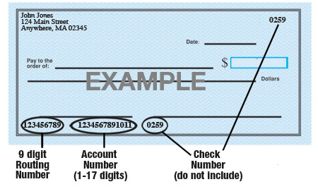
Account 1:
Name of Bank: ________________________________________________________________________________________________________
Type of Account: __________ Checking ___________ Savings
Bank’s 9-Digit Routing #: ____________________________________________________________
Your Bank Account #: _______________________________________________________________
Amount: ◻ Entire Paycheck or ◻ $ ________________ each paycheck or ◻ ____________% each paycheck
Account 2
Name of Bank: ________________________________________________________________________________________________________
Type of Account: __________ Checking ___________ Savings
Bank’s 9-Digit Routing #: ____________________________________________________________
Your Bank Account #: ____________________________________________________________
Amount: ◻ Entire Paycheck or ◻ $ ________________ each paycheck or ◻ _____________% each paycheck
Please attach a voided check for each bank account to which funds should be deposited.

I hereby authorize Independence Community College (ICC) to deposit funds into the account(s) indicated below. I also authorize ICC, if necessary, to withdraw funds from the account(s) below to correct any errors made. This authority is to remain in full force and effective until ICC receives written notice from me to terminate the direct deposit, allowing a reasonable amount of time for ICC and the financial institution to act (generally, no less than 14 days prior to the scheduled pay date). I accept responsibility for notifying ICC of any change to my account’s status.

_________________________________________________________________ _________________________________________
Employee Signature Date

Section 2:
This section MUST be filled out by your financial institution if you do not have a voided deposit slip or check to attach to the bottom of this form.

Name of Bank (Financial Institution): _______________________________________________________________________________

Address: _______________________________________________________________________________________________________________

City: _______________________________________________________ State: __________________ Zip code: ______________________

Telephone number_____________________________________________________________________________________________________

The information provided in Section 1 is identical the customer information on file at the bank: ◻Yes ◻No

Please enter account numbers EXACTLY as they need to appear for employee’s Direct Deposit to be successful:

Receiver’s Bank 9-Digital Routing Number: _________________________________________________________________________

Receiver’s Account Number: _________________________________________________________________________________________

Bank Representative’s Name: _______________________________________________________________________________________

Signature: ____________________________________________________________________________________________________________

Date: ____________________________________________

