Annual

Program Review

Of

Health, Physical Education, & Recreation (HPR)

For

2019-2020

Prepared by
Brett Gilcrist

December 13, 2019

Table of Contents
1.0 Program Data and Resource Repository 2
1.2 Quantitative and Qualitative Data 2
Narrative: 2
3.0 Assessment of Student Learning Outcomes 3
3.2 Significant Assessment Findings 3
Narrative: 3
4.0 External Constituency and Significant Trends 4
4.1: Program Advisory Committee: 4
Narrative: 4
4.2: Specialized Accreditation: 4
Narrative: 4
4.3: Other: 4
Narrative: 4
5.0 Curriculum Reflection 5
Narrative: 5
5.2 Degree and Certificate Offerings or Support 5
Narrative: 5
8.0 Fiscal Resource Requests/Adjustments 6
8.1 Budget Requests/Adjustments 6
Narrative: 6
9.0 Program Planning and Development Participation 7
9.1 Faculty and Staff 7
Narrative: 7
9.2 VPAA and/or Administrative Designee Response 7
Narrative: 7
10.0 Appendices 8

1.0 Program Data and Resource Repository
1.2 Quantitative and Qualitative Data
All programs are provided with the most recent two years of data by the Office of Institutional Research (IR) as well as two-year budget data provided by the Business Office.
The data sets provided by the Office of Institutional Research include the following elements for the most recent two (completed) academic years:
- Number of Faculty (Full Time; Part Time; Total)
- Student Credit Hours by Faculty Type
- Enrollment by Faculty Type
- Faculty Name by Type
- Average Class Size, Completion, and Attrition
- Course Completion, Success and Attrition by Distance Learning v Face-to-Face
- Number of Degrees/Certificates Awarded
- Number of Graduates Transferring (if available from IR)
- Number of Graduates Working in Related Field (technical programs only)
- Expenditures and Revenues
Additional data may also be available for reporting from the Office of Institutional Research, as applicable. Requests for additional data must be made through a data request.
(See Section 1.2 in the Program Review Handbook for more information.)

Narrative:
HPR Program Review Data AY 2019
Number of Faculty:
full time: 1 (Gilcrist)
part time: 1 (Floyd)
Enrollment & Student credit hours by Faculty type:
Full time: 8 total credit hours taught, with 42 total students enrolled
Part time: 13 credit hours taught, 149 total students enrolled
Average Class size:
15.5 students in Face-to-Face classes
19.6 students in online classes
17.4 students across all courses
Completion rates:
94.6% face-to-face
99.0% online
96.9% all courses
Pass (‘D’ or better) rates:
89.8% face-to-face
86.6% online
88.1% all courses
Pass (‘C’ or better) rates:
88.6% face-to-face
81.4% online
84.9% all courses
Number of Majors: 0
Degrees Awarded: 0
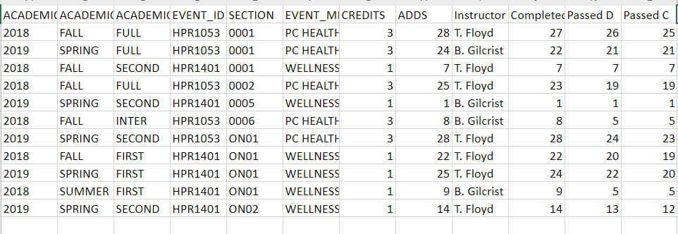

3.0 Assessment of Student Learning Outcomes
3.2 Significant Assessment Findings
The program faculty should provide a narrative overview of the program's significant student learning outcomes assessment findings, any associated impact on curriculum, as well as any ongoing assessment plans. The program may attach data charts, assessment reports or other relevant materials. (See Section 3.2 in the Program Review Handbook for more information.)

Narrative:
One big issue remains with HPR that has persisted for years now: 1) We have still not given someone the authority to oversee this program and ensure academic rigor and assessment.
When reviewing the data provided by Institutional Research, it is clear that students who enroll in HPR courses are successful. That said, we continued not receiving assessment data from part-time HPR instructors during the 2018-2019 academic year and rumors persisted that one instructor in particular was never holding class and handing out A’s even though no work was ever required. Unfortunately, the data provided by IR does not show these issues. Furthermore, it there is no guarantee that common assessments are being instituted across HPR-related courses without a singular person to serve as department chair (I, Brett Gilcrist, have been told in the past I would serve as this individual for HPR but nothing has ever to fruition after program review has been completed).
Although it is believed that many of the concerns related to assessment and rigor are slowly being addressed, it is critical that someone is given the authority to oversee this program and hold part-time instructors accountable. For two years we have said this would be done and yet administration has not followed through.

4.0 External Constituency and Significant Trends
An important component of maintaining a superior program lies in awareness and understanding of other possible factors that may impact the program and/or student outcomes. After consideration of these other factors, program faculty should document the relevant information within this section. As applicable, this should include the following.

4.1: Program Advisory Committee:

Narrative:
- IncludeAdvisory Member Name/ Title/ Organization/ Length of Service on committee; note the Committee Chair with an asterisk (*).
- Upload meeting minutes from the previous spring and fall semesters and attach in the appendices section (10.0).

Not applicable

4.2: Specialized Accreditation:
- Include Accrediting Agency title, abbreviation, ICC contact; Agency contact, Date of Last Visit, Reaffirmation, Next Visit, FY Projected Accreditation Budget.
- Upload the most recent self-study and site visit documents.
- Upload agency correspondence which confirm accreditation status.

Narrative:
Not applicable

4.3: Other:
Discuss any external constituencies that may apply to the program. (See Section 4.3 in the Program Review Handbook for more information.)

Narrative:
Currently, only Personal and Community Health is articulated through the KBOR matrix assuring it will transfer across the State’s public colleges and universities.
Also, given the college’s accreditation with the Higher Learning Commission it is important to note the HPR program helps ICC meet the following HLC criteria:
- 3A – The institution’s degree programs are appropriate to higher education.
- 3B – The institution demonstrates that the exercise of intellectual inquiry and the acquisition, application, and integration of broad learning and skills are integral to its educational programs.
- 3C – The institution has the faculty and staff needed for effective, high-quality programs and student services.
- 3D – The institution provides support for student learning and effective teaching.
- 4A – The institution demonstrates responsibility for the quality of its educational programs.
- 4B – The institution demonstrates a commitment to educational achievement and improvement through ongoing assessment of student learning.
- 4C – The institution demonstrates a commitment to educational improvement through ongoing attention to retention, persistence, and completion rates in its degree and certificate programs.

5.0 Curriculum Reflection
5.1 Reflection on Current Curriculum
The program faculty should provide a narrative reflection that describes the program’s curriculum holistically. The following are prompts formulated to guide thinking/reflection on curriculum. While presented in question form, the intent of the prompts is to stimulate thought and it is not expected that programs specifically answer each and every question.
- Is the curriculum of the program appropriate to the breadth, depth, and level of the discipline?
- How does this program transfer to four-year universities? (give specific examples)
- What types of jobs can students get after being in your program? (Please use state and national data)
- How dynamic is the curriculum? When was the last reform or overhaul?
- In the wake of globalization, how “internationalized” is the curriculum?
- How does the program assess diversity?
- Does the program have any community-based learning components in the curriculum?

Narrative:
The HPR program of study was updated last year to align with the college’s new Liberal Studies degree and to ensure it offered students the best potential transfer opportunity. The program of study was also updated to ensure it met KBOR requirements as it previously offered far too many free electives and not enough General Education requirements. As it is currently structured, the program is designed to offer students a general foundation in HPR-related studies while acknowledging there is a wide spectrum of majors and degrees that could pursue within the discipline. Below is the program of study as shown in the current course catalog:
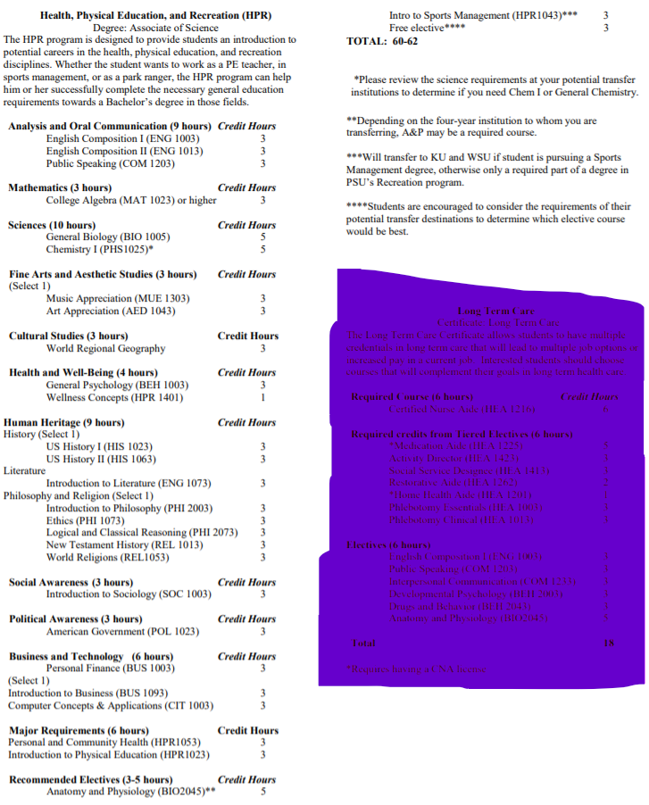

5.2 Degree and Certificate Offerings or Support
Program faculty should list what degrees and certificates are offered and/or describe how the program curriculum supports other degrees and/or certificates awarded by the college.

Narrative:
The HPR program is an Associate’s of Science degree. That said, Personal and Community Health and Wellness Concepts are both General Education options in ICC’s Liberal Studies degree and both are common options during the first two years of almost any Bachelor’s degree at Kansas four-year institutions.

8.0 Fiscal Resource Requests/Adjustments
8.1 Budget Requests/Adjustments
Based on program data review, planning and development for student success, program faculty will complete and attach the budget worksheets to identify proposed resource needs and adjustments. These worksheets will be available through request from the college’s Chief Financial Officer. Program faculty should explicitly state their needs/desires along with the financial amount required.
Programs should include some or all of the following, as applicable, in their annual budget proposals:
- Budget Projections (personnel and operation)
- Position Change Requests
- Educational Technology Support
- Instructional Technology Requests
- Facilities/Remodeling Requests
- Capital Equipment
- Non-Capital Furniture & Equipment
- New Capital Furniture & Equipment
- Replacement Capital Furniture & Equipment
- Other, as applicable
- Accreditation Fee Request
- Membership Fee Request
- Coordinating Reports
Resource requests should follow budgeting guidelines as approved by the Board of Trustees for each fiscal year. The resource requests should be used to provide summary and detailed information to the division Dean and other decision-makers and to inform financial decisions made throughout the year.

Narrative:
Assuming all budget requests from the zero-based budget worksheets are approved, the only thing that remains is empowering the full-time faculty member within this discipline to play more of a role in ensuring assessment and rigor within the discipline. The funds for that were requested, but no conversations have taken place and no contracts have been discussed to ensure change actually occurs for the better. Otherwise, this program does not require any additional funding at this time.
The budget data from 2018-19 is provided below:
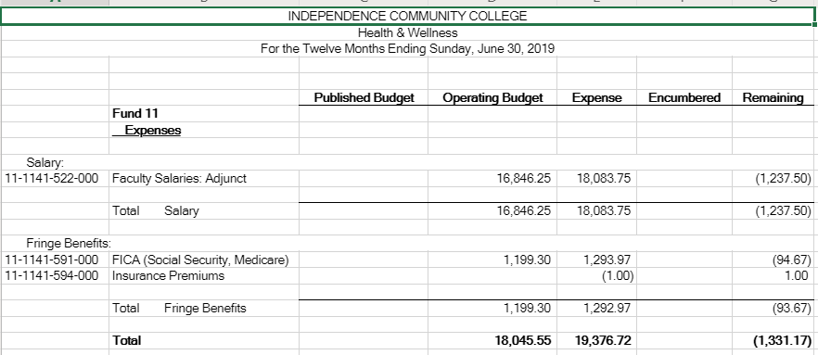

9.0 Program Planning and Development Participation
9.1 Faculty and Staff
Program faculty will provide a brief narrative of how faculty and staff participated in the program review, planning and development process. List the preparer(s) by name(s).

Narrative:
This program review was completed by Brett Gilcrist with the data provided by Anita Chappuie (IR) and Jonathan Sadhoo (CFO).
9.2 VPAA and/or Administrative Designee Response
After review and reflection of the Comprehensive Program Review or the Annual Program Review, the Division Chair and VPAA will write a summary of their response to the evidence provided. The Division Chair and VPAA’s response will be available to programs for review and discussion prior to beginning the next annual planning and development cycle.

Narrative:
The Program Review Committee has reviewed and approved the findings and recommendations of this report. We encourage the VPAA to name Professor Brett Gilcrist the Program Lead and imbue him with the authority to monitor assessment and rigor in the classes named in this program.

10.0 Appendices
Any additional information that the programs would like to provide may be included in this section.
The following pages provide the lone course-level assessment data submitted for all HPR-related courses during the 2018-19 academic year:
Wellness Concepts (HPR 1401) – Summer 2018
Outcomes, Measures, and Assessment Data

Outcome 1: Explain foundational concepts and terminology appropriate to wellness.
Seventy percent of students will correctly answer 75% of the following questions on the course post-test: #1, 4, 6, 8, and 9.
ON01: 3 of 6 (50%) students correctly answered 75% of questions 1, 4, 6, 8, and 9 on the course post-test.

Outcome 2: Analyze healthy decisions and how they contribute to maintaining a healthy lifestyle.
Seventy percent of students will correctly answer 75% of the following questions on the course post-test: #2, 3, 5, 7, and 10.
ON01: 3 of 6 (50%) students correctly answered 75% of questions 2, 3, 5, 7, and 10 on the course post-test.

One hundred percent of students will write SMART goals related to their future health and wellness and score a 70% or higher on the activity.
ON01: 6 of 7 (86%) completed the SMART goals activity at a 70% or higher.

Outcome 3: Describe the nutritive value of selected foods and how they relate to physical and mental health.
Seventy percent of students will score a 70% or higher on their calorie count assignment.
ON01: 4 of 6 (67%) scored a 70% or higher on their calorie count assignment.

Seventy percent of students will score a 70% or higher on their diet research assignment (#4).
ON01: 7 of 7 (100%) scored a 70% or higher on the diet research assignment.

Outcome 4: Examine one’s own personal wellness.
One hundred percent of students will complete the UND Wellness Assessment and write a 2-page reflection paper examining the results at a 70% or higher.
ON01: 9 of 9 (100%) completed a Wellness Assessment and reflection at a 70% or higher.

Seventy percent of students will average a 70% or higher on their discussion posts throughout the course.
ON01: 6 of 9 (67%) averaged a 70% or higher on their discussion posts.

Personal and Community Health (HPR 1053) – Fall 2018
Assessment Measures

Outcome 1: Gather, analyze and utilize information to make decisions that promote personal and community health and wellness.
Seventy percent of students will average 70% or higher on their four projects.
0006: 4 of 4 (100%)
***5 of 5 (100%) scored 70% or higher on the four knowledge inventories that accompanied each project

Outcome 2: Differentiate among dimensions of wellness as they apply to overall health.
Seventy percent of students will score 70% or higher on their Wellness Assessment reflection.
0006: 6 of 6 (100%)

Seventy percent of students will average 70% or higher on their four projects.
0006: 4 of 4 (100%)
***5 of 5 (100%) scored 70% or higher on the four knowledge inventories that accompanied each project

Outcome 3: Demonstrate the knowledge and skills for developing personal responsibility in health choices and quality of life.
Seventy percent of students will average 70% or higher on their four projects.
0006: 4 of 4 (100%)
***5 of 5 (100%) scored 70% or higher on the four knowledge inventories that accompanied each project

Outcome 4: Recognize the importance of demographic diversity as it applies to health and wellness issues.
Seventy percent of students will average 70% or higher on their four projects.
0006: 4 of 4 (100%)
***5 of 5 (100%) scored 70% or higher on the four knowledge inventories that accompanied each project

Wellness Concepts (HPR 1401) – Spring 2019
Outcomes, Measures, and Assessment Data

Outcome 1: Explain foundational concepts and terminology appropriate to wellness.
Seventy percent of students will correctly answer 75% of the following questions on the course post-test: #1, 4, 6, 8, and 9.
0005: 1 of 1 (100%) students correctly answered 75% of questions 1, 4, 6, 8, and 9 on the course post-test.

Outcome 2: Analyze healthy decisions and how they contribute to maintaining a healthy lifestyle.
Seventy percent of students will correctly answer 75% of the following questions on the course post-test: #2, 3, 5, 7, and 10.
0005: 1 of 1 (100%) students correctly answered 75% of questions 2, 3, 5, 7, and 10 on the course post-test.

One hundred percent of students will write SMART goals related to their future health and wellness and score a 70% or higher on the activity.
0005: 1 of 1 (100%) completed the SMART goals activity at a 70% or higher.

Outcome 3: Describe the nutritive value of selected foods and how they relate to physical and mental health.
Seventy percent of students will score a 70% or higher on their calorie count assignment.
0005: 1 of 1 (100%) scored a 70% or higher on their calorie count assignment.

Seventy percent of students will score a 70% or higher on their diet research assignment (#4).
0005: 1 of 1 (100%) scored a 70% or higher on the diet research assignment.

Outcome 4: Examine one’s own personal wellness.
One hundred percent of students will complete the UND Wellness Assessment and write a 2-page reflection paper examining the results at a 70% or higher.
0005: 1 of 1 (100%) completed a Wellness Assessment and reflection at a 70% or higher.

Seventy percent of students will average a 70% or higher on their discussion posts throughout the course.
0005: 1 of 1 (100%) averaged a 70% or higher on their discussion posts.

Personal and Community Health (HEA 1053) – Spring 2019
Assessment Measures

Outcome 1: Gather, analyze and utilize information to make decisions that promote personal and community health and wellness.
Seventy percent of students will average 70% or higher on their four projects.
Overall:
0001: 13 of 22 (59%)
***21 of 22 (95%) scored 70% or higher on the four knowledge inventories that accompanied each project

Outcome 2: Differentiate among dimensions of wellness as they apply to overall health.
Seventy percent of students will score 70% or higher on their Wellness Assessment reflection.
Overall:
0001: 20 of 20 (100%)

Seventy percent of students will average 70% or higher on their four projects.
Overall:
0001: 13 of 22 (59%)
***21 of 22 (95%) scored 70% or higher on the four knowledge inventories that accompanied each project

Outcome 3: Demonstrate the knowledge and skills for developing personal responsibility in health choices and quality of life.
Seventy percent of students will average 70% or higher on their four projects.
Overall:
0001: 13 of 22 (59%)
***21 of 22 (95%) scored 70% or higher on the four knowledge inventories that accompanied each project

Outcome 4: Recognize the importance of demographic diversity as it applies to health and wellness issues.
Seventy percent of students will average 70% or higher on their four projects.
Overall:
0001: 13 of 22 (59%)
***21 of 22 (95%) scored 70% or higher on the four knowledge inventories that accompanied each project

