Annual

Program

Of

Pre-Nursing

For

2019-2020

Prepared by
Dr. Thomas Weaver

12/12/2019

Table of Contents
1.0 Program Data and Resource Repository 2
1.2 Quantitative and Qualitative Data 2
Narrative: 2
3.0 Assessment of Student Learning Outcomes 5
3.2 Significant Assessment Findings 5
Narrative: 5
4.0 External Constituency and Significant Trends 6
4.1: Program Advisory Committee: 6
Narrative: 6
4.2: Specialized Accreditation: 6
Narrative: 6
4.3: Other: 6
Narrative: 6
5.0 Curriculum Reflection 8
Narrative: 8
5.2 Degree and Certificate Offerings or Support 9
Narrative: 9
8.0 Fiscal Resource Requests/Adjustments 11
8.1 Budget Requests/Adjustments 11
Narrative: 11
9.0 Program Planning and Development Participation 12
9.1 Faculty and Staff 12
Narrative: 12
9.2 VPAA and/or Administrative Designee Response 12
Narrative: 12
10.0 Appendices 13

1.0 Program Data and Resource Repository
1.2 Quantitative and Qualitative Data
All programs are provided with the most recent two years of data by the Office of Institutional Research (IR) as well as two-year budget data provided by the Business Office.
The data sets provided by the Office of Institutional Research include the following elements for the most recent two (completed) academic years:
- Number of Faculty (Full Time; Part Time; Total)
- Student Credit Hours by Faculty Type
- Enrollment by Faculty Type
- Faculty Name by Type
- Average Class Size, Completion, and Attrition
- Course Completion, Success and Attrition by Distance Learning v Face-to-Face
- Number of Degrees/Certificates Awarded
- Number of Graduates Transferring (if available from IR)
- Number of Graduates Working in Related Field (technical programs only)
- Expenditures and Revenues
Additional data may also be available for reporting from the Office of Institutional Research, as applicable. Requests for additional data must be made through a data request.
(See Section 1.2 in the Program Review Handbook for more information.)

Narrative:
The Pre-Nursing program at Independence Community College offers introductory courses in Biology, including, Biology I, Anatomy and Physiology, Chemistry, and Microbiology as well as electives such as Nutrition and Medical Terminology. These courses provide an excellent foundation for students to continue their education in Nursing or at a four-year college or in a health-related program.
The courses in Pre-Nursing at ICC are taught by three full time faculty members and four part-time faculty members. The three full time faculty members have diverse specializations from molecular and organismal biology to medical and health care that complement the course offerings. All courses in the Biological Sciences at ICC have a maximum of 24 students, allowing students to receive individualized attention, ample opportunities for active class participation, and accurate advisement.
Studying Pre-Nursing increases an understanding and appreciation of medical situations along with an understanding of the human body and chemistries. In addition, studying Pre-Nursing creates scientific thinking, reasoning, problem solving skills and the ability to relate to real world experiences.
A career in Pre-Nursing can be very exciting and rewarding. Nurses work in fields such as health care, research, Nurse Anesthetist, Mental Health, Nurse Practitioner, Certified Nurse Midwife, Pediatric Nurse, Orthopedic Nurse, Nurse Practitioner, Clinical Nurse Specialist, Geriatric Nurse, Neonatal Nurse amongst many others. With recent advances in science and medical research, many more doors and avenues are opening for students with degrees in Pre-Nursing.
The two-year associate degree in Pre-Nursing at Independence Community College is designed as a transfer program for completion at a four-year institution or for completion in a health-related program such as an LPN program, BSN program, or NP program.
For detailed information about careers in Nursing, please visit http://albs.org/careers/Nursing.
PRN Program Review Data AY 2019
*Looking at all courses from the “Sciences” section of the degree plan.
Number of Faculty:
full time: 3 (Chaplin, Weaver, Crompton)
part time: 4 (Reynolds, Dahler, Pearce, Lal)
Enrollment & Student credit hours by Faculty type:
Full time: 96 total credit hours taught, with 312 total students enrolled
Part time: 28 credit hours taught, 63 total students enrolled
Average Class size:
14.1 students in Face-to-Face classes
15.7 students in online classes
14.4 students across all courses
Completion rates:
90.4% face-to-face
77.7% online
87.2% all courses
Pass (‘D’ or better) rates:
98.4% face-to-face
82.2% online
94.8% all courses
Pass (‘C’ or better) rates:
87.4% face-to-face
71.2% online
83.8% all courses
Number of Majors: 21 (3 returned in Fall 2019)
Degrees Awarded: 1

3.0 Assessment of Student Learning Outcomes
3.2 Significant Assessment Findings
The program faculty should provide a narrative overview of the program's significant student learning outcomes assessment findings, any associated impact on curriculum, as well as any ongoing assessment plans. The program may attach data charts, assessment reports or other relevant materials. (See Section 3.2 in the Program Review Handbook for more information.)

Narrative:
In striving to meet its institutional responsibilities as a community college, Independence Community College sets forth the following purpose statements in definition of its educational programs and services. These statements also serve as criteria for the administration, faculty, staff, students, and the public in assessing the College's effectiveness in meeting its institutional mission. The following is the student learning outcomes assessment for the Pre-Nursing program.
The Pre-Nursing program adopted the learning outcome in response to the impact the curriculum provides for students that will transfer to other institutions for additional nursing degree.
- Achieving Junior Level Transfer Status
Students who have completed either a prescribed Associate of Arts or Associate of Science degree programs at Independence Community College should be able to transfer to select four-year colleges or universities with junior status. The College establishes and maintains transfer agreements with select institutions to facilitate the transferability of its academic programs.
The assessment for the courses in the Pre-Nursing program took part in the new assessment format created by the ICC assessment committee. The template included a summary table, the outcome, whether outcome was met, findings, further action, strengths of course, weaknesses of course, measures used, measure target goal, and measure results. Assessment templates were completed for the Biology department courses by the instructors for all courses except for the Nutrition course taught by adjunct instructor Dr. Archana Lal’s during the summer 2018 as these templates were not available at that time.
Target success for a learning outcome is that 70% of the students will achieve a 70% on a measure corresponding to the learning outcome. Learning outcomes are considered “Met” if the average score for a learning outcome is at 70% or higher. Outcomes are “Partially Met” if scored in the 55-69% range, and “Not Met” for outcomes less than 55%. The range for Partially Met is scored to match current trends in the number of students who obtain a grade of “C” or higher.

4.0 External Constituency and Significant Trends
An important component of maintaining a superior program lies in awareness and understanding of other possible factors that may impact the program and/or student outcomes. After consideration of these other factors, program faculty should document the relevant information within this section. As applicable, this should include the following.

4.1: Program Advisory Committee:

Narrative: There is no committee that serves as an advisory to the department
- IncludeAdvisory Member Name/ Title/ Organization/ Length of Service on committee; note the Committee Chair with an asterisk (*).
- Upload meeting minutes from the previous spring and fall semesters and attach in the appendices section (10.0).

4.2: Specialized Accreditation:
- Include Accrediting Agency title, abbreviation, ICC contact; Agency contact, Date of Last Visit, Reaffirmation, Next Visit, FY Projected Accreditation Budget.
- Upload the most recent self-study and site visit documents.
- Upload agency correspondence which confirm accreditation status.

Narrative:The Pre-Nursing program does not have any specialized accreditation.

4.3: Other:
Discuss any external constituencies that may apply to the program. (See Section 4.3 in the Program Review Handbook for more information.)

Narrative:
Higher Learning Commission HLC's Category One: Helping students learn focuses on the design, deployment, and effectiveness of teaching-learning process that underlie the institution's credit and non-credit programs and courses.

Kansas Board of Regents
Transfer and Articulation Agreement for the following courses:
- General Biology
- Biology I
- Biology II
- A&P
- Microbiology
- Nutrition
- Medical Terminology
- Environmental Science
- Chemistry I
- Chemistry II

5.0 Curriculum Reflection
5.1 Reflection on Current Curriculum
The program faculty should provide a narrative reflection that describes the program’s curriculum holistically. The following are prompts formulated to guide thinking/reflection on curriculum. While presented in question form, the intent of the prompts is to stimulate thought and it is not expected that programs specifically answer each and every question.
- Is the curriculum of the program appropriate to the breadth, depth, and level of the discipline?
- How does this program transfer to four-year universities? (give specific examples)
- What types of jobs can students get after being in your program? (Please use state and national data)
- How dynamic is the curriculum? When was the last reform or overhaul?
- In the wake of globalization, how “internationalized” is the curriculum?
- How does the program assess diversity?
- Does the program have any community-based learning components in the curriculum?

Narrative:
An associate degree in Pre-Nursing requires a completed application, completion of 65 credit hours, including the fulfillment of all program and degree requirements, and a cumulative GPA of 2.0 or better.
The Associates of Science Degree in Pre- Nursing is intended to enable students to satisfy equivalent lower-division college credit course requirements and to transfer, with advanced standing, into comparable Bachelor of Science Degree programs at Kansas Regents universities or to enter a healthcare Nursing program at another college or university.
Courses are organized and structured to interconnect accumulative knowledge with growing proficiencies within each course for an overall informative experience of the program.
Courses are modified across outcomes whether through assessment, interaction with transfer institution, or knowledge of the profession.
The Biology program, with collaboration and guidance from KBOR, adapts and modifies the educational needs of the community it serves.
Due to the curriculum and courses offered for the program, the budget falls within the Biology department. Therefore, the future plan is for the Pre-Nursing program to become a tract within the Biology program beginning the 2020-2021 academic year.
5.2 Degree and Certificate Offerings or Support
Program faculty should list what degrees and certificates are offered and/or describe how the program curriculum supports other degrees and/or certificates awarded by the college.

Narrative:
Graduation Requirements for the associate of Science degree in Pre-Nursing (PRN):
The Associate of science Degree is awarded upon satisfactory completion of a planned program of not less than sixty-five (65) college credit hours and a cumulative grade point average of 2.0 including the following distribution of credits:
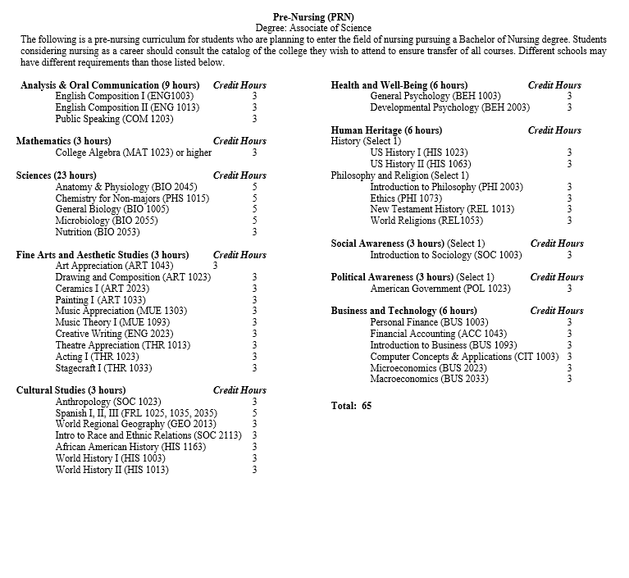

8.0 Fiscal Resource Requests/Adjustments
8.1 Budget Requests/Adjustments
Based on program data review, planning and development for student success, program faculty will complete and attach the budget worksheets to identify proposed resource needs and adjustments. These worksheets will be available through request from the college’s Chief Financial Officer. Program faculty should explicitly state their needs/desires along with the financial amount required.
Programs should include some or all of the following, as applicable, in their annual budget proposals:
- Budget Projections (personnel and operation)
- Position Change Requests
- Educational Technology Support
- Instructional Technology Requests
- Facilities/Remodeling Requests
- Capital Equipment
- Non-Capital Furniture & Equipment
- New Capital Furniture & Equipment
- Replacement Capital Furniture & Equipment
- Other, as applicable
- Accreditation Fee Request
- Membership Fee Request
- Coordinating Reports
Resource requests should follow budgeting guidelines as approved by the Board of Trustees for each fiscal year. The resource requests should be used to provide summary and detailed information to the division Dean and other decision-makers and to inform financial decisions made throughout the year.

Narrative:
The Pre-Nursing program does not have its own budget line. Due to the curriculum and courses offered for the program, the budget falls within the Biology department. Therefore, the plan is for the Pre-Nursing program to become a tract within the Biology program beginning the 2020-2021 academic year.

9.0 Program Planning and Development Participation
9.1 Faculty and Staff
Program faculty will provide a brief narrative of how faculty and staff participated in the program review, planning and development process. List the preparer(s) by name(s).

Narrative:
Dr. Thomas Weaver prepared this Annual Program Review for the aforementioned academic years for the ICC Pre-Nursing Department. Anita Chappuie (Director of institutional Research) provided end of year academic data.
9.2 VPAA and/or Administrative Designee Response
After review and reflection of the Comprehensive Program Review or the Annual Program Review, the Division Chair and VPAA will write a summary of their response to the evidence provided. The Division Chair and VPAA’s response will be available to programs for review and discussion prior to beginning the next annual planning and development cycle.

Narrative:
Division Chair of Science, Technology & Industry, Tamara Blaes, agrees with the findings in this program review.
The Program Review Committee agrees with the findings and recommendations in this review and encourages the development of a separate pre-nursing track with appropriate funding.

10.0 Appendices
Any additional information that the programs would like to provide may be included in this section.

